An Evaluation of the Non-Lethal Hazing of Gulls (Larus spp.) at Lower Columbia River Dams, 2005

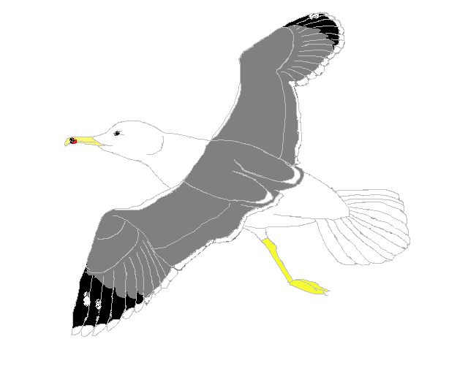
By
Mike Jonas

John T. Dalen
Patricia L. Madson
and
Sallie T. Jones

U.S. Army Corps of Engineers
CENWP-OD-SRF
Fisheries Field Unit
Bonneville Lock and Dam
Cascade Locks, Oregon 97014
(541) 374-8801

January 31, 2008

EXECUTIVE SUMMARY

To reduce dam-passage related mortalities of juvenile salmon from feeding gulls, a variety of techniques have been employed. Such techniques have included the ‘lethal take’ of what were considered problem birds; however, little empirical evidence exists as to whether lethal measures are necessary. The primary objective of this study was to determine the efficacy of non-lethal hazing techniques (both active and passive) on the presence, distribution, and persistence of gulls feeding on juvenile salmonids in the tailrace areas of Bonneville, The Dalles, and John Day dams.

Active hazing was conducted using a variety of visual and auditory techniques (e.g., rockets, 15mm fire crackers, and cracker shells fired from a shotgun). After hazing, gulls departed hazed areas, however, numbers typically returned to near pre-hazing levels during the sixty minutes following the hazing event. Gulls were dispersed again with subsequent hazing (indicating non-lethal hazing techniques retained some effectiveness over time). Similar results occurred during ‘lethal take’ (Jones et al. 1998, 1999), though an empirical comparison in the return timing and number of returning birds is beyond the scope of this study. Gull presence and distribution were not stable at any monitored area, being characterized by birds randomly arriving and departing. Because of the lack of a controlled study environment, we were unable to determine whether gulls were habituating to hazing over the course of the season.

Passive techniques (avian lines) were also evaluated in this study and were generally effective, however, were subject to factors including site characteristics and line maintenance. For instance, avian lines were not an effective deterrent to gull predation at The Dalles Dam’s spillway tailrace, presumably related to the height and wide spacing of the lines. Also, some gulls were observed near the spillway of Bonneville Dam, probably for reasons similar to those noted for The Dalles.

TABLE OF CONTENTS

EXECUTIVE SUMMARY………………………………. iii

LIST OF TABLES AND FIGURES…………………….. vii

INTRODUCTION
BACKGROUND…….……………………………………… 1
OBJECTIVE………………………………………………… 2 SITE DESCRIPTIONS………………………………........... 2

METHODS NON-LETHAL HAZING…………………………………… 5
AVIAN LINES…………..………………………………….. 6

RESULTS
SEASONAL DISTRIBUTION ……….…………………..... 7
NON-LETHAL HAZING…………………………………… 8
AVIAN LINES…………..………………………………….. 13

DISCUSSION…………………………………………….. 13

NOTES…………………………………………………….. 14

RECOMMENDATIONS…………………………………. 15

ACKNOWLEDGMENTS………………………………… 15

REFERENCES……………………………………………. 16

APPENDIX………………………………………………… 17

LIST OF TABLES AND FIGURES

LIST OF TABLES

Table 1. Number of sixty minute Hazing and Non-hazing Observations collected at the three lower Columbia River dams in 2005. 7

LIST OF FIGURES

Figure 1. Map of the Columbia River Basin illustrating the locations of the 2005

study sites. 2

Figure 2. Bonneville Dam avian deterrent line array locations in 2005. 3

Figure 3. The Dalles Dam avian deterrent line array locations in 2005. 4
Figure 4. John Day Dam avian deterrent line array locations in 2005. 5

Figure 5. Daily mean of gulls counted at the beginning of each observation period (hazing and non-hazing) at Bonneville, The Dalles, and John Day dams in 2005. 7

Figure 6. The effect of non-lethal hazing measured over a sixty minute period after
hazing events for all three lower Columbia River dams in 2005. 8

Figure 7. The mean number of gulls counted during sixty minute observations for both
hazing and non-hazing treatments at Bonneville Dam in 2005. 9

Figure 8. The mean number of gulls and mean estimated take (of fish) following hazing
over ten minute blocks for sixty minutes at Bonneville Dam in 2005. 9

Figure 9. The mean number of gulls counted during sixty minute observations for both

hazing and non-hazing treatments at The Dalles Dam in 2005. 10

Figure 10 The mean number of gulls and mean estimated take (of fish) following hazing
over ten minute blocks for sixty minutes at The Dalles Dam in 2005. 11

Figure 11.The mean number of gulls counted during sixty minute observations for both hazing and non-hazing treatments at John Day Dam in 2005. 12

Figure 12.The mean number of gulls and mean estimated take (of fish) following hazing
over ten minute blocks for sixty minutes at John Day Dam in 2005. 12

INTRODUCTION

BACKGROUND

Salmon and steelhead (Oncorhynchus spp.) populations in the Columbia and Snake River basins are declining and many risk extinction (NMFS 2004; McClure et al. 2003). Causes for declines include, but are not limited to, exploitation rates, land use practices, and hydroelectric impoundment effects (Raymond 1979, 1988; ISG 2000). Impacts to salmonids associated with dam passage have been the primary focus of federal mitigation in the Columbia River basin (NPPC 1986), as hydroelectric dams are known to reduce survival of endemic stocks (Raymond 1969, 1979: Venditti 2000). Juvenile salmonids are particularly vulnerable to predation by gulls (Larus spp.) due to disorientation and stunning induced by pressure changes, turbulence, and shear forces associated with dam-passage events (ISG 2000; Budy et al. 2002).

Techniques to ameliorate such dam passage related mortality on juvenile salmonids include both active and passive measures. Passive measures include the use of avian lines over point source (bypass outfalls) and general source water discharge areas downstream from each dam’s powerhouse and spillway. Active hazing measures include the use of auditory and visual deterrents, and have gone as far as ‘lethal take’ of what were believed to be problem birds. To investigate the need for ‘lethal take’, the U.S. Army Corps of Engineers (USACE) Fisheries Field Unit (FFU) was commissioned to evaluate the effects of non-lethal hazing techniques.

The U.S. Department of Agriculture (USDA) Wildlife Services Division was contracted by the USACE in 1995 to lethally ‘take’ gulls as a deterrence method. The U.S. Fish and Wildlife Service permit stipulated that this method would be a measure of last resort, not being employed until non-lethal measures had been demonstrated ineffective. To date, there is not sufficient empirical evidence to support or refute lethal methods being required to deter feeding gulls. To address the need for such data, the FFU was directed to evaluate the effect of non-lethal hazing on the presence, distribution, and persistence of gulls feeding on juvenile salmonids at Bonneville, The Dalles, and John Day dams in 2005. We evaluated gull activity during the juvenile salmon passage season. Of particular interest were the bypass outfalls and the dam’s spillway and powerhouse tailraces where juvenile salmon are disoriented due to dam passage events.

In order to provide fish adequate recovery time following dam passage, a system of protective stainless steel lines have been used to occlude avian predators from optimal feeding areas below dams. Mylar streamers were added to these lines, enhancing the deterrent effect by increasing the visibility of the array as a whole. Mylar streamers are also considered to offer avian species of concern (i.e., Peregine Falcons Falco peregrinus) an additional margin of safety by virtue of increased visibility. An assessment of how well the existing avian line arrays excluded gull predation was also made in conjunction with the non-lethal hazing evaluation.

OBJECTIVE

Evaluate the use of non-lethal hazing techniques (e.g. visual and auditory deterrents) and exclusion by avian lines at lower Columbia River dams to determine their effectiveness in reducing juvenile salmonid loss to gull predation from April through July of 2005.

SITE DESCRIPTIONS

This evaluation was conducted at three hydroelectric dams where the Columbia River serves as the border between Oregon and Washington. Bonneville Dam is located at river mile 146.1 (235.1 km) and is the first hydroelectric dam on the river (traveling upstream from the ocean). The Dalles and John Day dams are located at river miles 191.5 (308.1 km) and 215.6 (346.9 km) respectively (Figure 1).

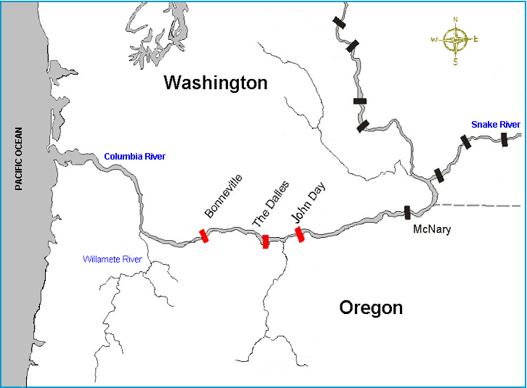

Figure 1. Map of the Columbia River Basin illustrating the locations of the 2005 study sites.

Bonneville Dam

Bonneville Dam is located at a site where the river channel is separated by two islands, Cascades Island (man-made) on the north and Bradford Island on the south. The First Powerhouse (PH1) extends from the Oregon shore to Bradford Island; the Second Powerhouse (PH2) connects Cascades Island with the Washington shore. A spillway dam, with 18 vertical lift gates, bridges Bradford and Cascades Islands. Each of the three channels includes a north and south adult fishway entrance. At PH2, juvenile fish are
routed away from turbine intakes by submerged traveling screens into a transportation flume and delivered to the Smolt Monitoring Facility (SMF) located on the Washington shore downstream of the dam. A newly modified sluiceway at PH2, referred to as the corner collector, channels fish from the southern corner of the forebay to a downstream exit at the tip of Cascades Island (Figure 2).

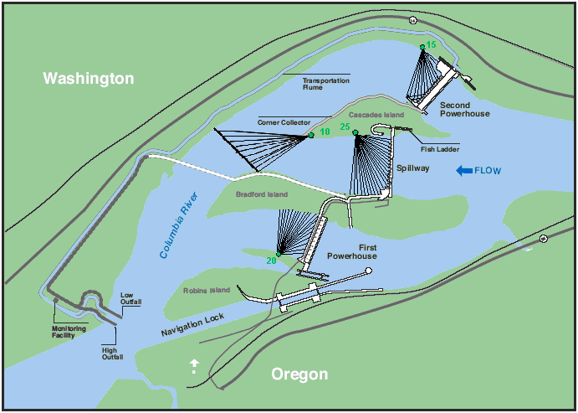

Figure 2. Bonneville Dam avian deterrent line array locations in 2005.

Four large, avian line arrays cover the PH1, PH2, and spillway tailrace channels as well as the corner collector outfall area at the tip of Cascades Island. Rotating high-pressure agricultural impulse sprinklers, termed avian hydro-cannons, are permanently mounted on the SMF outfall chute.

The Dalles Dam

The Dalles Dam is “L” shaped with the spillway being perpendicular to river flow and the powerhouse parallel to it. The spillway stretches from the Washington shore to a non-overflow section located mid-river. This non-overflow section and the powerhouse lie parallel to the flow of the river with the powerhouse connecting to the Oregon shore. The spillway has 23 tainter gates numbered from north to south 1–23. A training wall extends into the tailrace between spill bays 6 and 7 directing spill discharge flows from bays 1-6 down river away from the shallow rocky shelf on the Oregon shore. An ice and trash sluiceway outfall, located at the downstream end of the powerhouse, offers another route past the dam for downstream migrants (Figure 3).

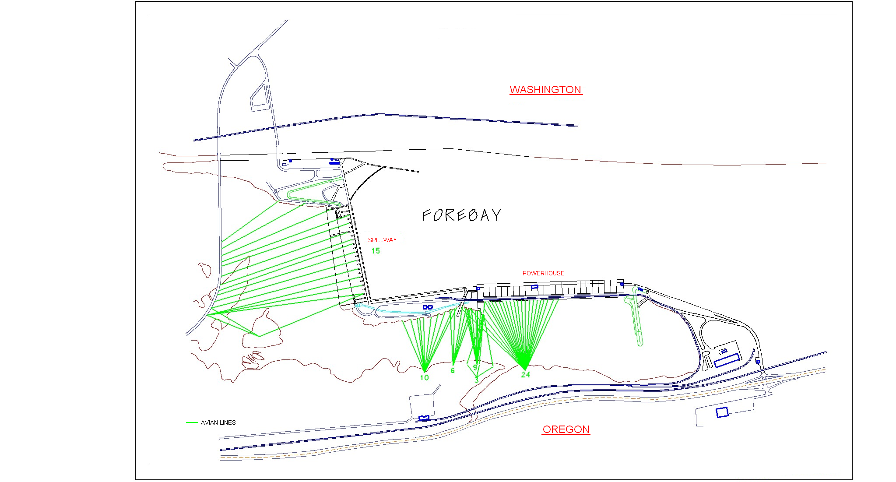

Figure 3. The Dalles Dam avian deterrent line array locations in 2005.

Avian line arrays at The Dalles Dam cover the tailrace areas of the spillway, the western portion of the powerhouse, and the outfall of the ice and trash sluiceway. The line array at the spillway is attached to the Highway 197 bridge (located downstream of the dam at river mile 191.4) and strung across the spill basin to the spillway piers. The other arrays originate from posts placed along the Oregon shore.

John Day Dam

John Day Dam crosses the river in a straight line connecting Oregon and Washington. The spillway and navigation lock are on the north side with the powerhouse and SMF on the south side. Like Bonneville Dam, it is equipped with screens that divert juvenile fish away from turbine units. These fish are routed through the SMF where they are sampled to determine juvenile run-timing and species composition, and also to monitor for injury and disease.

One large avian line array covers both the turbine boils, immediately below the powerhouse, and the SMF outfall pipe. The spillway basin is covered by a series of grouped arrays that are configured to cover both the spill basin and the shoreline adjacent to the navigation lock wing wall (Figure 4).

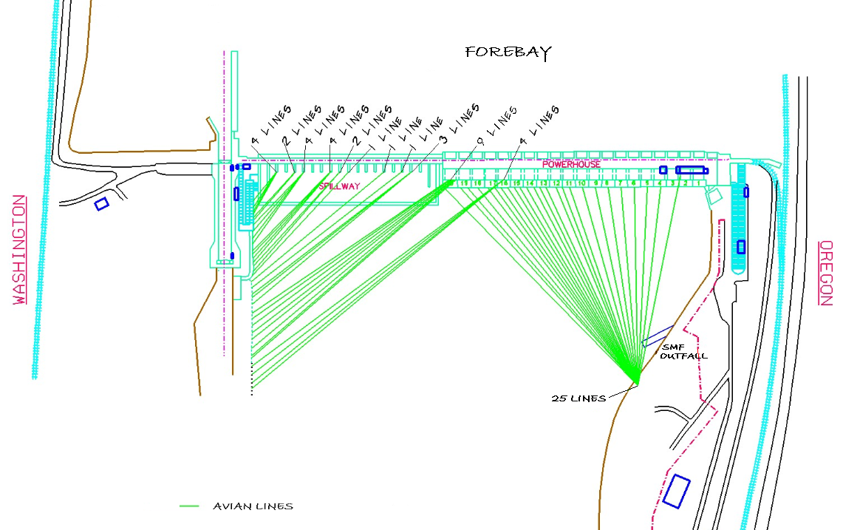

Figure 4. John Day Dam avian deterrent line array locations in 2005.

METHODS

non-lethal hazing

Gull Counts

Data collection was coordinated by FFU personnel to coincide with non-lethal hazing activities conducted by USDA Wildlife Services (WS) personnel. Areas with the greatest concentration of flying gulls were selected. Prior to hazing, FFU observers counted and recorded the number of gulls flying at the selected location. Non-lethal hazing was then conducted by WS personnel using a combination of pyrotechnic devices (e.g., rockets, 15mm fire crackers, and cracker shells fired from a shotgun). WS agents did not haze at the study location during the subsequent sixty minute observation period. The number of gulls present was enumerated at one minute; followed by counts at 10, 20, 30, 40, 50, and 60 minutes after hazing. Data was collected from 13 April through 29 July, 2005.

We attempted to collect four sixty-minute observations per day at Bonneville Dam, and four sixty minute observations at The Dalles and John Day dams combined. Observations of avian feeding behaviors were also made during times without hazing to provide a comparison between gull numbers during hazing and non-hazing treatments. These observations were recorded in the same manner as hazing observations, but without the one minute count. Sampling days were not separated by treatment, so some days included both treatments.

Predation Rates

Two classes of predation events were recorded in conjunction with hazing. A confirmed take was recorded when definitive evidence of such an event was observed (i.e., a fish in the mouth of a gull or other evidence that a fish had been consumed or injured). A probable take was recorded when it appeared as if a gull may have taken a fish, but the observer was unable to positively confirm a take. The number of takes and probable takes was enumerated during each ten minute block, for sixty minutes. Estimated take for each ten minute block was calculated by adding the number of confirmed takes to one-half the number of probable takes (confirmed takes + [0.5 X probable takes]). The mean estimated take for each ten minute block was used to represent the season’s estimated take for that block. Predation data was not collected with every observation because at some sites the birds were too far from the observer to accurately enumerate take.

Data Description

The seasonal distribution for each dam was described by 1.) Plotting the daily mean number of gulls counted at the beginning of each observation period (hazing and non-hazing) and 2.) Calculating the mean number of gulls before each observation (hazing and non-hazing) for the entire season.

Mean number of gulls observed and mean estimated take were plotted against the ten minute blocks of the observation period. We followed the methods of Jones et al. (1999), whereby sixty minute observation periods were employed. Variability is indicated using standard error (S_{x}) bars at depicted time intervals. For each dam, all sites were combined as patterns were similar at every location. Charts comparing gull numbers versus estimated take show only the number of gulls counted during observations when predation data was also taken.

AVIAN LINES

The effectiveness of avian lines was evaluated through the use of non-numeric methods that were specific to each site. Observation sites were chosen based on the availability of actively feeding (flying) gulls. In the course of the season, FFU personnel located the primary feeding locations of the gulls at all three dams. Whether or not a feeding area was located under avian lines array served as a measure of the array’s effectiveness as a deterrent.

RESULTS

SEASONAL DISTRIBUTION

Gulls appeared at John Day and Bonneville dams in mid-April. They didn’t appear at The Dalles until the end of May. Gull presence was not steady at any of the dams (Figure 5). The mean number of gulls (±S_{x}) counted prior to observations was 16.4 ± 1.16 for Bonneville (ranging from 0 to 95), 10.7 ± 0.80 for The Dalles (ranging from 0 to 75), and 10.4 ± 1.25 at John Day (ranging from 2 to 36). In addition to gulls, we observed other piscivorous avian predators during the study (Appendix A).

Figure 5. Daily mean of gulls counted at the beginning of each observation period (hazing and non-hazing) at Bonneville, The Dalles, and John Day dams in 2005.

Observations were made based on the availability of gulls feeding in the study area. The study was done in conjunction with the WS hazing program, which resulted in more hazing observations than non-hazing observations (Table 1).

Table 1. Number of sixty minute Hazing and Non-hazing Observations collected at the three lower Columbia River dams in 2005.

 | Hazing | Non-hazing
Bonneville Dam | 148 | 58
The Dalles Dam | 94 | 59
John Day Dam | 36 | 9

non-lethal hazing

Non-lethal hazing activity resulted in fewer gulls being present for the duration of the sixty minute observation period compared to the number present prior to the hazing. Observation results demonstrated that hazing had the greatest impact on gull presence immediately after the event, with the impact diminishing over each subsequent ten minute interval (Figure 6).

Figure 6. The effect of non-lethal hazing measured over a sixty minute period after hazing events at all three lower Columbia River dams in 2005.

Bonneville Dam

At Bonneville Dam observations were made from 18 April through 29 July. Gull feeding occurred primarily at the spillway channel, where due to this consistent presence, most of the hazing observations (n = 144) were taken. Also, limited hazing observations were taken in the PH2 tailrace (n = 2) and at the SMF outfall (n = 2). Gull activity typically occurred downstream of the avian lines at the spillway and PH2. Non-hazing observations where taken at the spillway (n = 57) and SMF outfall (n = 1).

Mean number of gulls (±S_{x}) present at the end of each ten minute block of non-hazing observations ranged from 11.7 ± 2.00 to 14.0 ± 2.30, whereas the number of gulls present following hazing observations ranged from a low of 1.1 ± 0.19 at one minute after hazing to a high of 13.2 ± 1.20 at sixty minutes after the hazing. The number of gulls at sixty minutes was 75.4% of the initial (pre-hazing) number (Figure 7).

Figure 7. The mean number of gulls counted during sixty minute observations of both hazing and non-hazing treatments at Bonneville Dam in 2005.

Predation, as measured by estimated take of fish (confirmed takes + [0.5 X probable takes]), was collected after non-lethal hazing at Bonneville Dam (n = 99). The mean estimated take (±S_{x}) [right y-axis] following hazing ranged from a low of 1.6 ± 0.35 in the ten minute block after hazing to a high of 5.6 ± 0.67 during the ten minute block ending at fifty minutes after hazing (Figure 8). Although we observed predation during periods without hazing, the data was collected at times when fewer gulls were actively feeding and biased the results for comparison, therefore we did not present this data here for comparison.
Figure 8. The mean number of gulls and mean estimated take (of fish) following hazing over ten minute blocks for sixty minutes at Bonneville Dam in 2005.

The Dalles Dam

Observations were made at The Dalles Dam from 23 May through 23 July. Gull feeding occurred primarily underneath the avian line array covering the spillway tailrace; all hazing observations (n = 94) were taken at this location. Non-hazing observations where taken at the spillway tailrace (n = 58) and the sluiceway outfall (n = 1).

Mean number of gulls (±S_{x}) present at the end of each ten minute block of non-hazing observations ranged from 8.1 ± 1.01 to 9.3 ± 1.21, whereas the number of gulls present following hazing observations ranged from a low of 0.3 ± 0.09 at one minute after hazing to a high of 10.7 ± 0.82 at fifty minutes after the hazing. The number of gulls at sixty minutes (also 10.7 ± 0.82) was 85.9% of the initial (pre-hazing) number (Figure 9).
Figure 9. The mean number of gulls counted during sixty minute observations for both hazing and non-hazing treatments at The Dalles Dam in 2005.

Predation data, as measured by estimated take of fish, was collected after non-lethal hazing at The Dalles Dam (n = 94). Estimated take (±S_{x}) [right y-axis] following hazing ranged from a low of 2.0 ± 0.33 in the ten minute block after hazing to a high of 5.0 ± 0.39 during the ten minute block ending at fifty minutes after hazing (Figure 10). Although we observed predation during periods without hazing, the data was collected at times when fewer gulls were actively feeding and biased the results for comparison, therefore we did not present this data here for comparison.
Figure 10. The mean number of gulls and mean estimated take (of fish) following hazing over ten minute blocks for sixty minutes at The Dalles Dam in 2005.

John Day Dam

We made observations at John Day Dam from 13 April through 13 July. During periods when the spillway gates were closed, gulls were typically observed either at the SMF outfall or in the powerhouse tailrace downstream of the avian lines (Figure 4). During times of spill, gulls were seen feeding at the downstream end of the navigation lock’s wing wall and in the spillway basin.

Hazing observations were taken at the SMF outfall (n = 19), the navigation lock wing wall (n = 11), the spillway (n = 3), and in the powerhouse tailrace (n = 3). Non-hazing observations were taken at the SMF outfall (n = 5) and the navigation lock wing wall (n = 4).

Mean number of gulls (±S_{x}) present at the end of each ten minute block of non-hazing observations ranged from 5.9 ± 2.23 to 8.4 ± 4.78, whereas the number of gulls present following hazing observations ranged from a low of 0.7 ± 0.30 at one minute after hazing to a high of 9.5 ± 2.00 at sixty minutes after the hazing. The number of gulls at sixty minutes was 83.4% of the initial (pre-hazing) number (Figure 11).
Figure 11. The mean number of gulls counted during sixty minute observations for both hazing and non-hazing treatments at John Day Dam in 2005.

Predation, as measured by estimated take of fish, was collected after non-lethal hazing at John Day (n = 33). Estimated take (±S_{x}) [right y-axis] following hazing ranged from a low of .36 ± 0.14 in the ten minute block after hazing to a high of 1.8 ± 0.45 during the ten minute block ending at fifty minutes after hazing (Figure 12). Although we observed predation during periods without hazing, the data was collected at times when fewer gulls were actively feeding and biased the results for comparison, therefore we did not present this data here for comparison.
Figure 12. The mean number of gulls and mean estimated take (of fish) following hazing compared over ten minute blocks for sixty minutes at John Day Dam in 2005.

AVIAN LINES

At Bonneville Dam, most feeding by gulls occurred in the spillway channel. Observers agreed that, for the most part, gulls remained downstream of the avian line array although a few were seen flying under the lines. At The Dalles Dam, feeding occurred primarily under the avian line array in the spillway tailrace; gulls would fly between the widely spaced and highly strung avian lines. The height and wide spacing allowed gulls to feed underneath and gave them an easy exit when they wanted to leave the feeding area. At John Day Dam, feeding by gulls occurred at more locations than at the other dams but, like Bonneville, it was mostly downstream of avian line arrays.

DISCUSSION

Non-lethal hazing was effective in reducing gull presence for up to sixty minutes after the hazing event. Following hazing, gull numbers dropped dramatically but gradually returned to 75.4% – 85.9% of pre-hazing numbers within sixty minutes. However, gull numbers did not return to pre-hazing levels at the end of sixty minutes suggesting that more frequent hazing may keep gulls away for longer periods of time.

Following hazing, as gull numbers increased over the sixty minute observation period, predation (as measured by mean estimated take of fish) increased for the first fifty minutes. Although we observed predation during periods without hazing, the data was collected at times when fewer gulls were actively feeding. Reduction of avian predation through hazing was given priority over collection of non-hazing data; because of this bias, the non-hazing results are not presented here. Predation was not measured prior to hazing, so a before-and-after comparison is not possible.

Gull presence and distribution were not stable at any monitored dam or area, being characterized by gulls arriving and departing on a regular basis. Since we were not able to study isolated groups, it was difficult to determine if habituation to hazing was occurring over time or if the effectiveness of hazing lessened over the course of the season.

When properly located and maintained, avian line arrays proved an effective means of excluding gulls from feeding in most areas. Because these arrays provide a continual deterrence to avian predation they are an effective means of reducing predation associated with dam passage on juvenile salmonids.

NOTES

Bonneville Dam

Gulls in the vicinity of Bonneville Dam quickly recognized and took advantage of the opportunities that the presence of sea lions (Zalophus californiensis) offered. As sea lions fed on adult salmonids, low-flying gulls had ample time to pick up small fragments of fish resulting from pinniped predation. This behavior would disrupt observations when gulls would leave the study area to take advantage of this feeding opportunity.

The Dalles Dam

The Dalles Dam is located in an area of agricultural production, including fruit orchards, especially cherries. Feeding on juvenile fish appeared to be curtailed as this food became available. Gulls were confirmed to be feeding at cherry orchards upriver in Wishram, Washington in 2005 by WS agent Ken Richter (personal communication). In July, a solid waste disposal site near the city of The Dalles attracted as many as two hundred gulls that remained at the site during daylight hours. Also in July, most of the gulls present at the dam were immature; these immature gulls tended to congregate on tailrace rock outcroppings between feeding forays.

John Day Dam

At John Day, data collection was seriously curtailed due to gulls moving to the forebay to feed. The forebay population included many newly arrived immature gulls, easily distinguished from adults by plumage differences. The forebay feeding behavior was sufficiently different from tailrace feeding behavior that these late season observations where not used here. The observations used for this report only include gulls that were flying; this served as our working definition of ‘feeding’. In the forebay, floating gulls caught juvenile fish that were coming very close to the surface or jumping out of the water. Project biologists Robert Cordie and Miro Zyndol (personal communication), and FFU technician Patricia Madson (personal observation) identified numbers of smallmouth bass (Micropterus dolomieui) pursuing juvenile salmonids to the surface. This activity, readily seen by floating gulls, made the forebay a lucrative feeding location for them.

RECOMMENDATIONS

1. Continue the current hazing program, increasing the frequency of hazing as needed to prevent gulls from returning to their optimal feeding locations.

2. Maintain all existing avian line arrays, including mylar streamers.

3. Expand the areas covered by avian line arrays downstream of the Bonneville Dam spillway tailrace.

4. Lower and reduce the spacing between the avian lines presently covering The Dalles Dam spillway tailrace.

5. Expand the areas covered by avian line arrays along the navigation lock peninsula of the John Day Dam tailrace. Install a hydro-cannon at the downstream end of the John Day Dam navigation lock peninsula, taking advantage of the prevailing westerly winds.

6. Devise a means to exclude gulls from resting on structures proximate to feeding locations (e.g., SMF and sluiceway outfalls, spill walls, navigation lock peninsulas).

ACKNOWLEDGMENTS

The authors would like to thank the WS agents for their cooperation in coordinating their non-lethal hazing measures to coincide with data collection periods. Bill Nagy assisted in data collection, data description, and interpretation. Karrie (Ewald) Gibbons, Paolo Lazatin, and Lukas Wikstrom also assisted in a variety of duties including data collection, data entry, and data proofing. We would also like to thank Robert Wertheimer and Marie Kopka for their contributions to this project.

REFERENCES

Budy, P., G.P. Thiede, N. Bouwes, C.E. Petrosky, and H. Schaller. 2002. Evidence
linking delayed mortality of Snake River salmon to their earlier hydro system
experience. North American Journal of Fisheries Management 22:35-51.

Independent Scientific Group (ISG). 2000. Return to the river: restoration of salmonid
fishes in the Columbia River ecosystem. Northwest Power Planning Council,
NWPPC 2000-12, Portland, Oregon.

Jones, Sallie T., Gretchen M. Starke, and Robert J. Stansell. 1998. Predation by Birds
and Effectiveness of Predation Control Measures at Bonneville, The Dalles, and
John Day Dams in 1997. U.S. Army Corps of Engineers, CENPP-CO-SRF. 22 pp.

Jones, Sallie T., Gretchen M. Starke, and Robert J. Stansell. 1999. Predation by Gulls
and Effectiveness of Predation Control Measures at Bonneville, The Dalles, and
John Day Dams, 1998. U.S. Army Corps of Engineers, CENPP-CO-SRF. 17 pp.

Northwest Power Planning Council (NPPC). 1986. Council Staff Compilation of
Information on Salmon and Steelhead Losses in the Columbia River Basin.
Appendix D, 1987 Columbia River Basin Fish and Wildlife Program. 252 pp.

McClure, M.M., E.E. Holmes, B.L. Sanderson, and C.E. Jordon. 2003. A large-scale
multi-species status assessment: anadromous salmonids in the Columbia Basin.
Ecology Applications 13 (4): 964-989.

NMFS (National Marine Fisheries Service). 2004. Endangered Species Act status of
west coast salmonids, June 17, 2004. NMFS, Northwest Region, Portland, OR.
Available: http://www.nwr.noaa.gov (accessed 30 September 2005).

Raymond, H.L. 1969. Effects of John Day Reservoir on the migration rate of juvenile
chinook salmon in the Columbia River. Transactions of the American Fisheries
Society 98:513-514.

Raymond, H.L. 1979. Effects of dams and impoundment on migration of juvenile
chinook salmon and steelhead from the Snake River, 1966-1975. Transactions of
the American Fisheries Society 108: 505-529.

Raymond, H.L. 1988. Effects of hydroelectric development and fisheries enhancement
on spring and summer chinook salmon and steelhead in the Columbia River basin.
North American Journal of Fisheries Management 8:1-24.

Venditti, D.A., D.W. Rondorf, and J.M. Kraut. 2000. Migratory behavior and forebay
delay of radio-tagged juvenile fall chinook salmon in a lower Snake River
impoundment. North American Journal of Fisheries Management 20:41-52.

APPENDIX A

PISCIVOROUS AVIAN PREDATORS

During the study period in the forebay and tailrace areas at Bonneville, The Dalles, and John Day dams we identified a variety of piscivorous birds. These include:

California Gulls Larus californicus
Ring-billed Gulls L. delawarensis
Western Gull L. occidentalis
Herring Gulls L. argentatus
Bonaparte Gulls, L. Philadelphia (infrequent)
Glaucus-winged Gulls L. glaucescens (Bonneville Dam only)
Bald Eagles Haliaeetus leucocephalus
Osprey Pandion haliaetus
Belted Kingfishers Megaceryle alcyon
Great Blue Herons Ardea Herodias
Common Mergansers Mergus merganser
Western Grebes Aechmophorus occidentalis
Double-crested Cormorants Phalacrocorax auritus
American White Pelicans Pelecanus erythrorhynchos (John Day Dam only) Caspian Terns Hydroprogne caspia (infrequent and small numbers)

